NEXTGEN TELEHEALTH DOCUMENTATION
STEPS
- FRONT DESK WILL PLACE PATIENT ON APPOINTMENT SCHEDULE
  - Select Telehealth as Visit type
    - 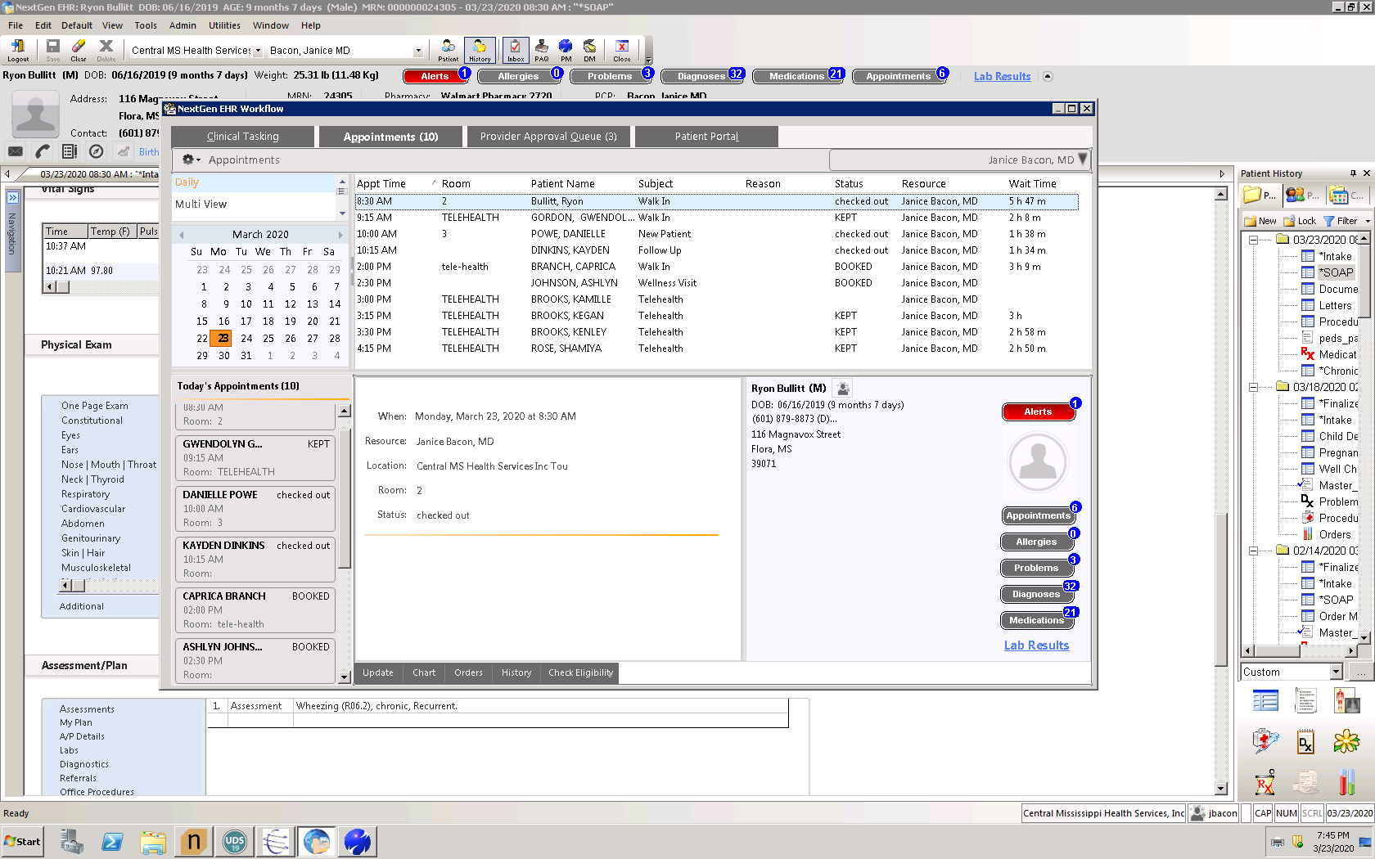
- PROVIDER SELECT TELEPHONE CALL TEMPLATE
  - 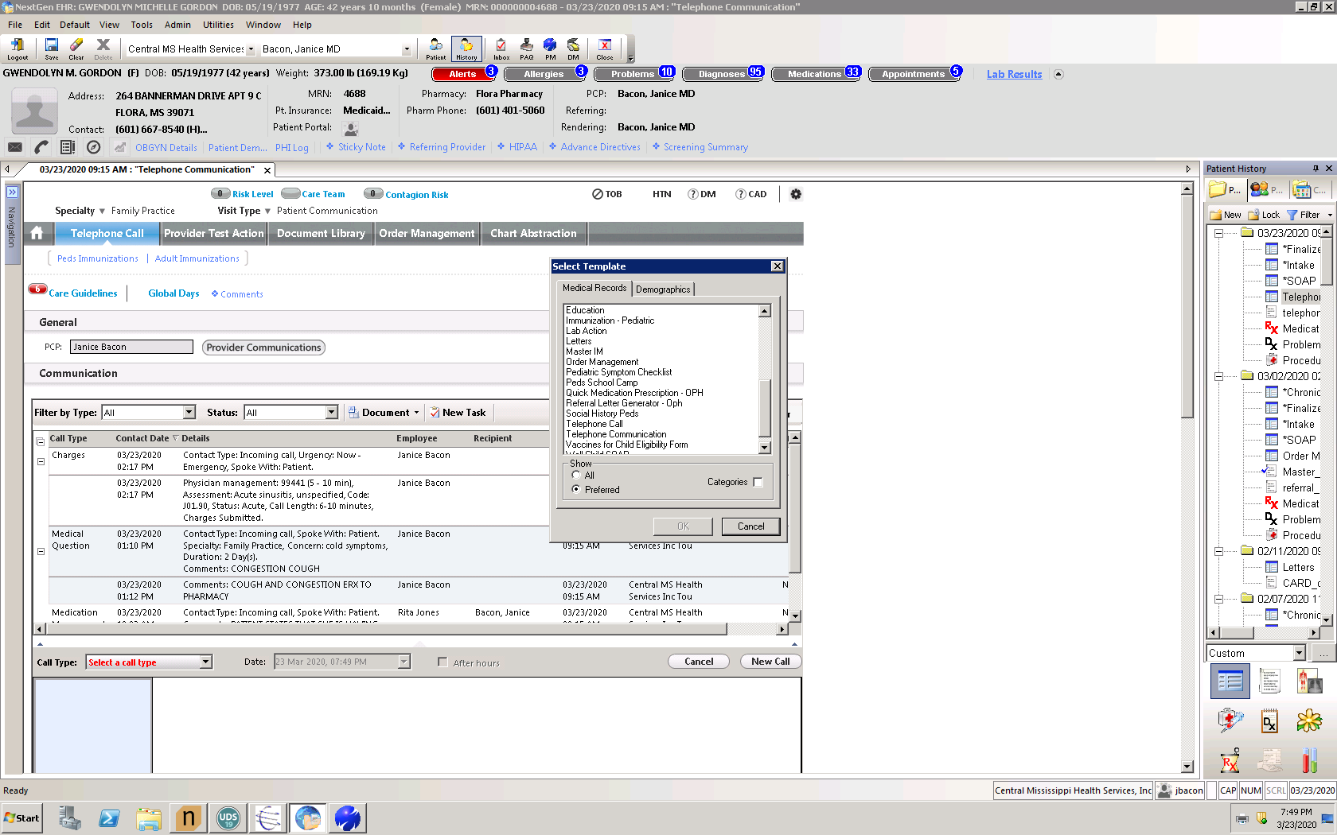

- SELECT MEDICAL QUESTION AND COMPLETE INFORMATION; SELECT CHARGES AFTER COMPLETION OF MEDICAL INFORMATION ON FAR RIGHT 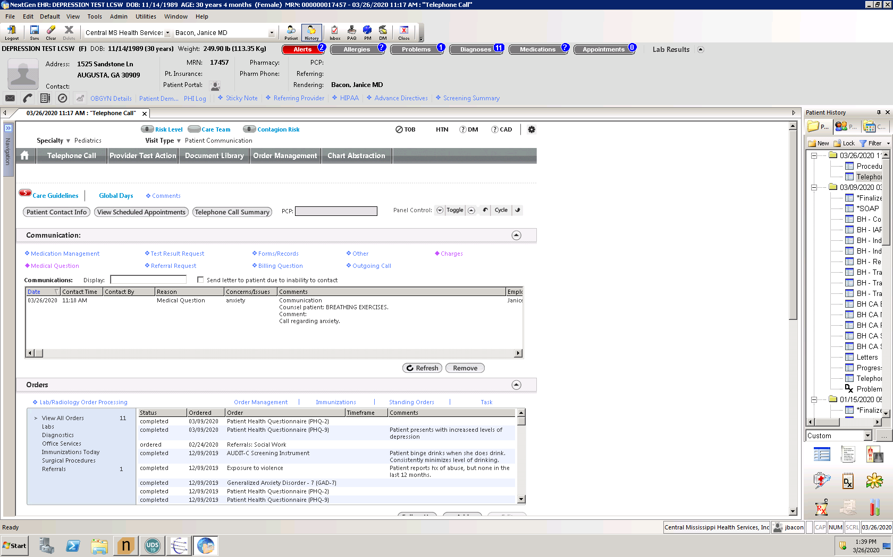

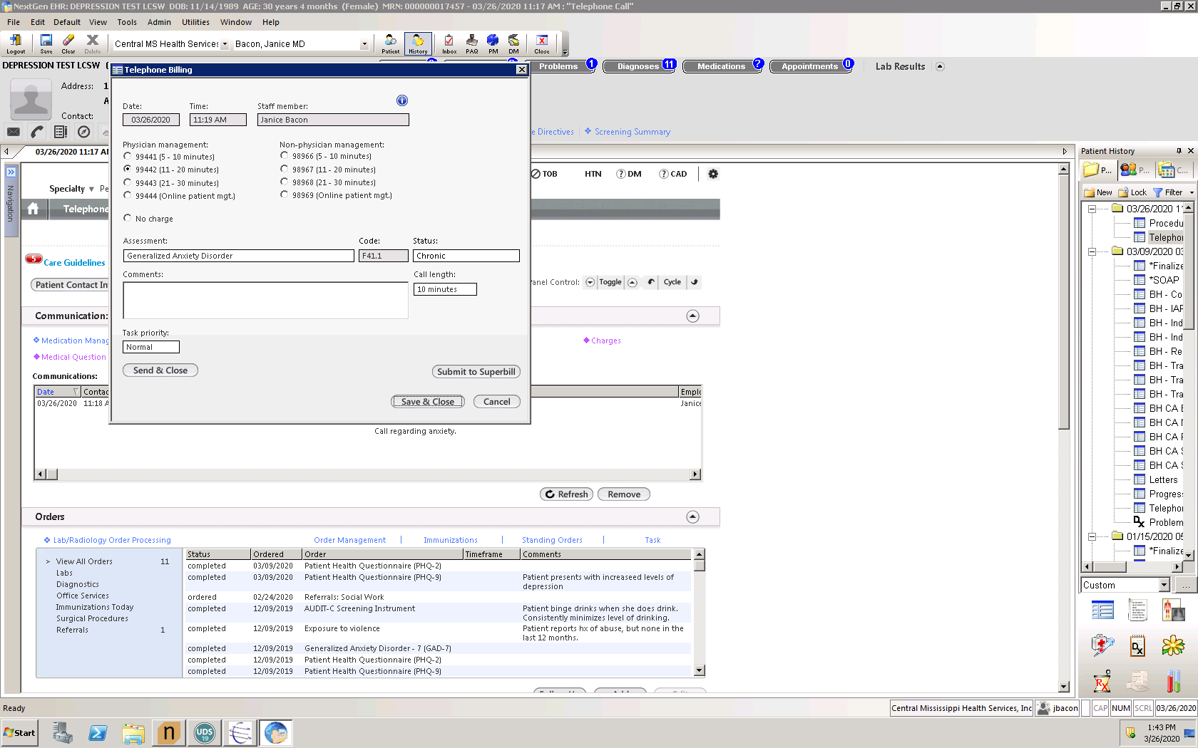
- SELECT NUMBER OF MINUTES, ADD DIAGNOSIS, STATUS, CALL LENGTH AND SUBMIT TO SUPERBILL

